LAB 1 : Creating a UML class diagram and sequence diagrams for the given question.

1. This was done by using Microsoft visio 2013, I followed all the instructions given in the tutorial to create this class diagram shown below. The sensors send information to the controller which checks the thresholds value of the sensors and determines its value and send's the alarm signal to main interface by which the user can access it. I have placed the controller and sensors in a control interface package.



Sequence diagrams



2.Creating a Git hub account for lab1.

a.

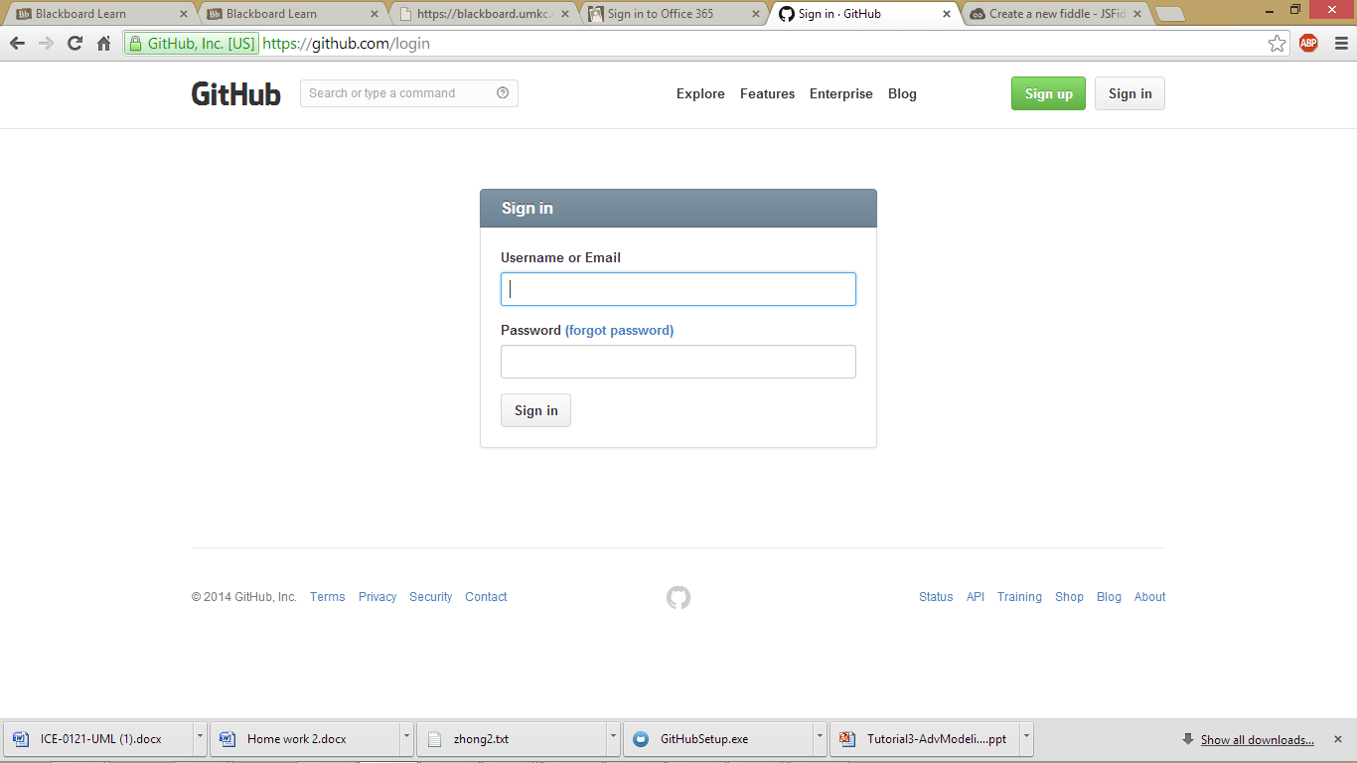

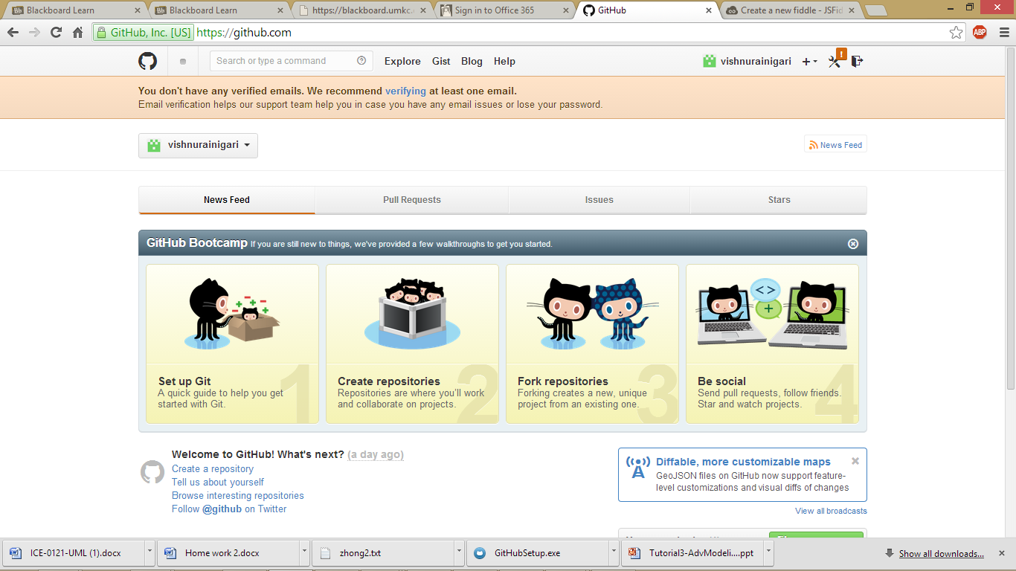

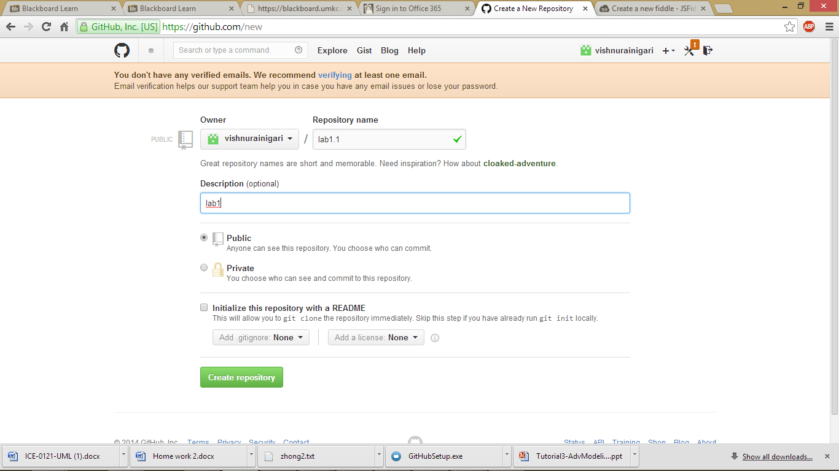



3. Creating a scrumdo account.

A. 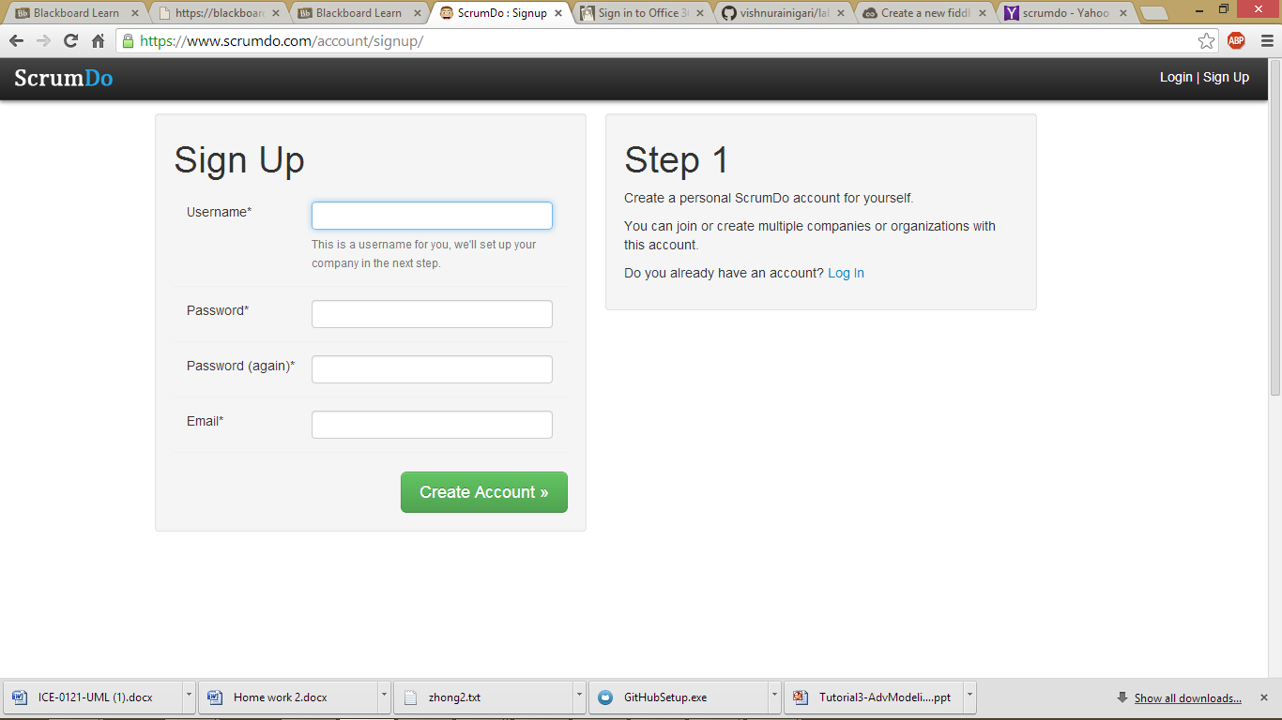

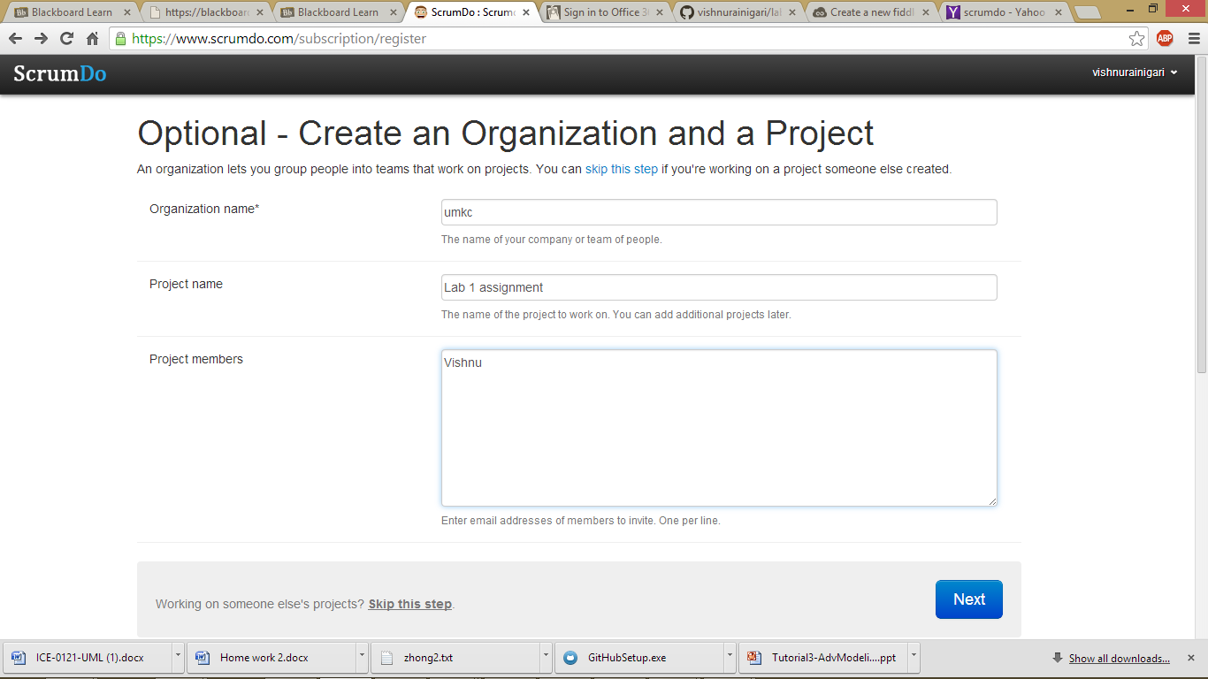

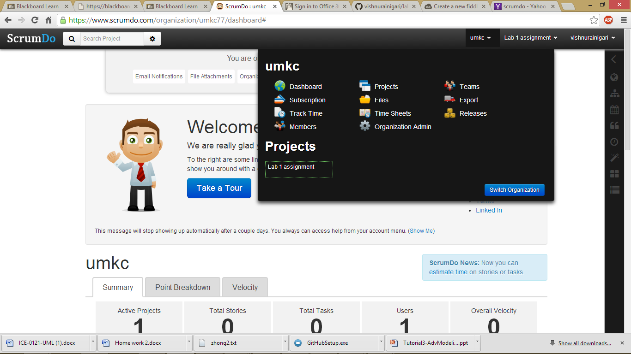

Adding iteration1

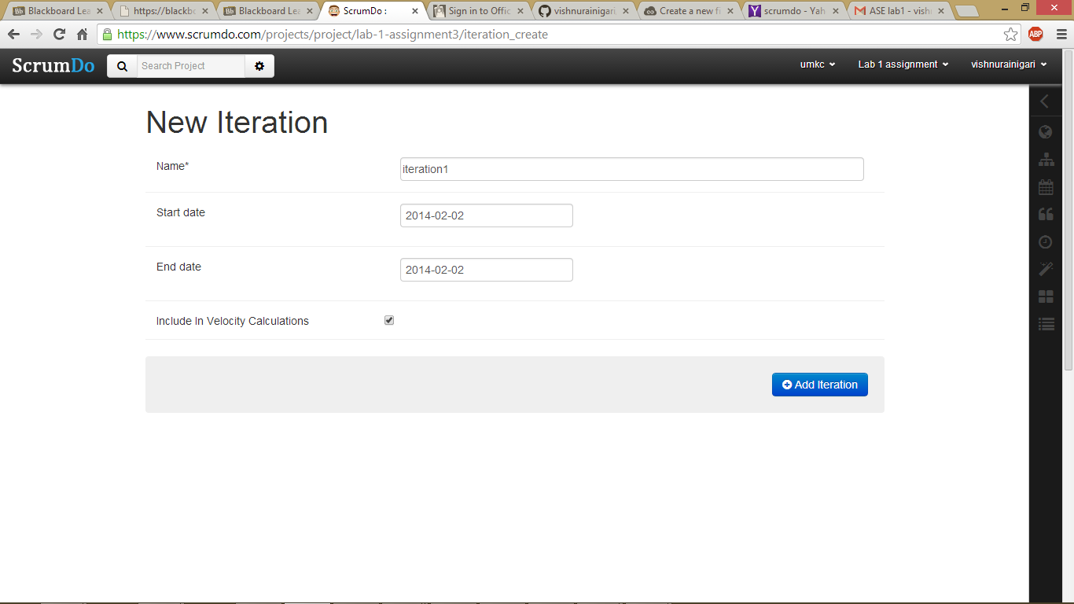

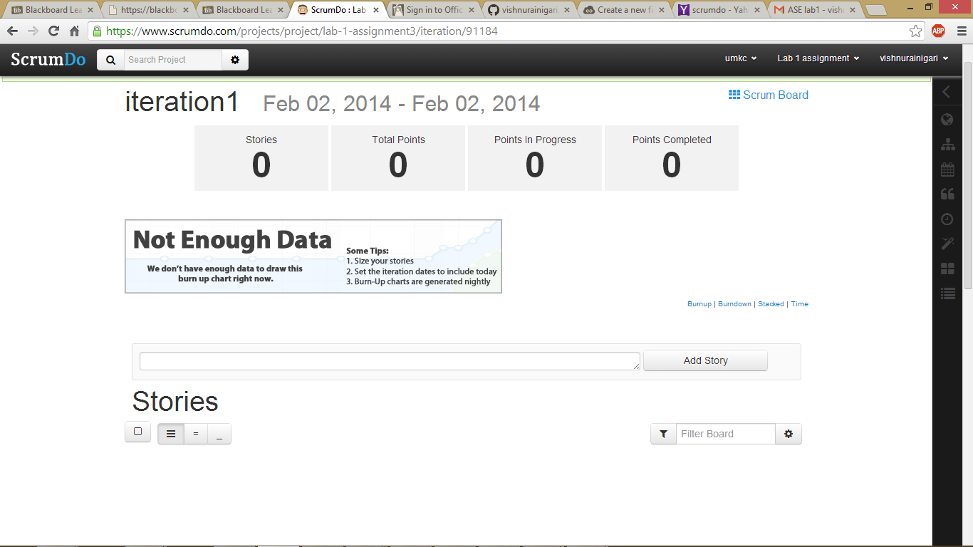

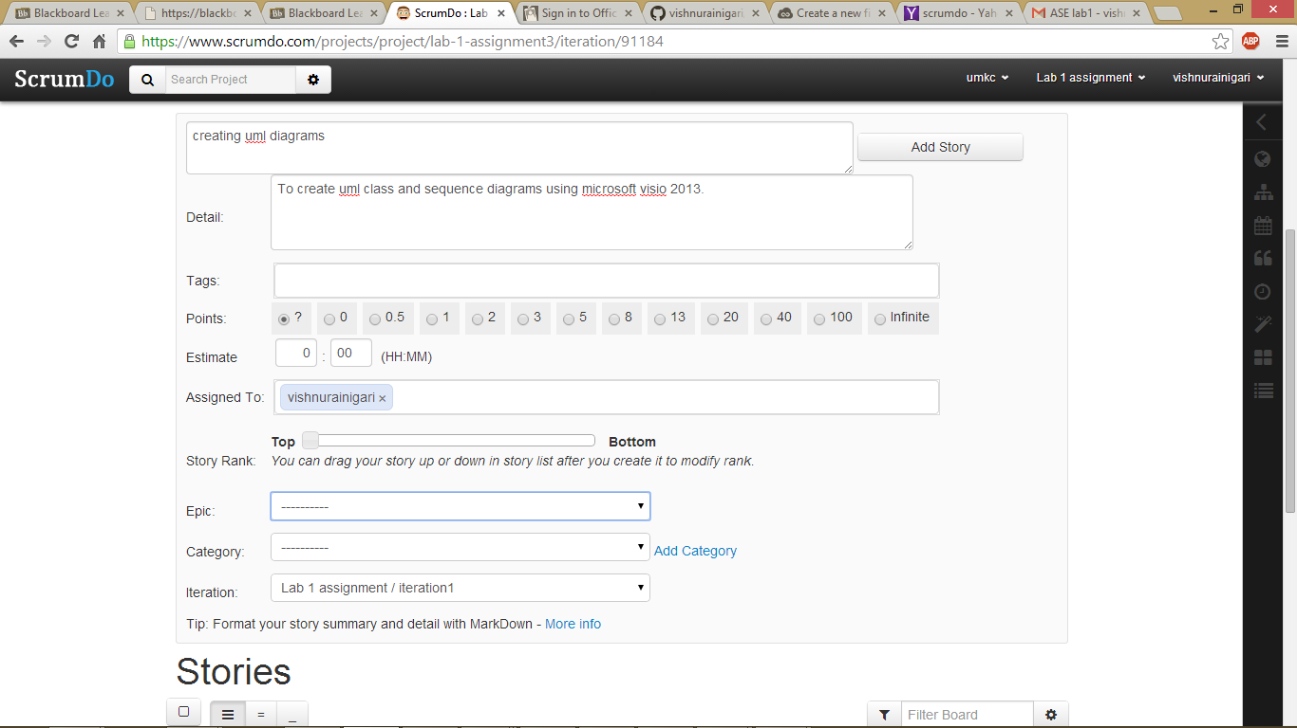

Creating an epic story.

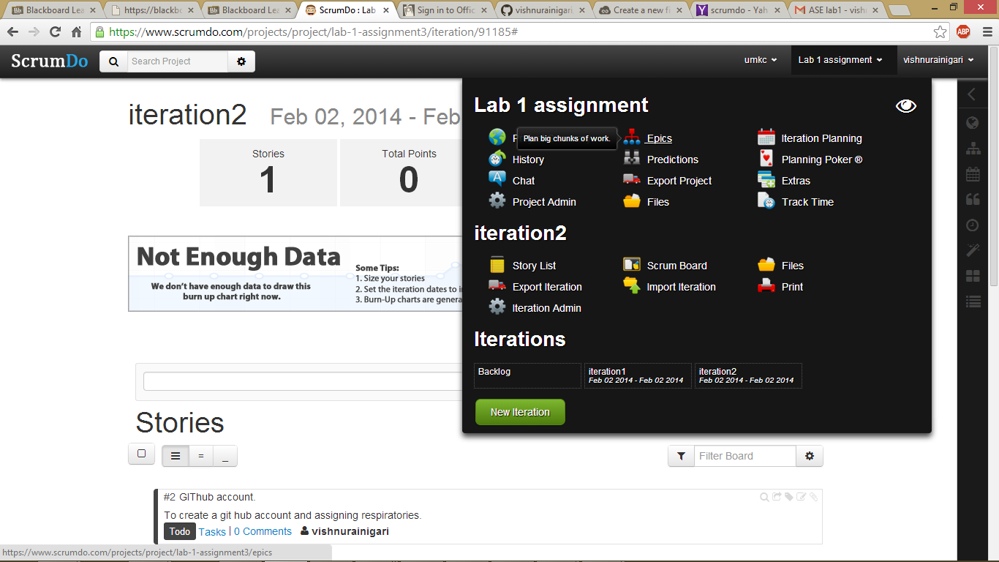

Scrum do

